14.1.1 Editors - Movie Clip Editor - Header Tools and Options
Movie Clip Editor - Header 3
Movie Clip prop 3
List of clips in the scene 3
Search form 3
Clip Edit Box 3
Number of Fake Users 3
Fake User 3
Open 4
Remove 4
Info String 4
Pivot Point 4
Lock to Selection 4
Clip Display 5
Clip Display 5
R G B 5
BW 5
Mute Footage 5
Render Undistorted 5
Show Metadata 5
Show Stable 5
Grid 5
Calibration 5
Display Aspect Ratio X Y 5
Marker Display 5
Pattern 5
Search 6
Path 6
Length 6
Show Disabled 6
Info 6
3D Markers 6
Display Thin 6
Marker Tools 6
Refine Markers Backwards 6
Clear Track Path Backwards 6
Track Markers Backwards 6
Track Markers Sequence Backwards 6
Track Markers Sequence Forwards 7
Track Markers Forwards 7
Clear Track Path Forwards 7
Refine Markers Forwards 7
Graph editor Options 7
Only selected 7
Display Hidden 7
Show Frames 7
Show Track Motion 7
Show Tracks Error 7
Dopesheet editor Options 7
Only selected 7
Display Hidden 8
Dopesheet Sort Field 8
Invert 8
Proportional Editing 8
Proportional Editing 8
Settings 8
Mask Prop 8
Mask Prop 8
List of Masks 9
Mask Edit Box 9
Fake User 9
Search form 9
Mask Display 9
Mask Display 9
Smooth 9
Overlay 9
Edge Display Type 9

Movie Clip Editor - Header

The Movie Clip Editor has two modes, and is three editors in one. So we have to explain the single header tools and options at a one by one base.

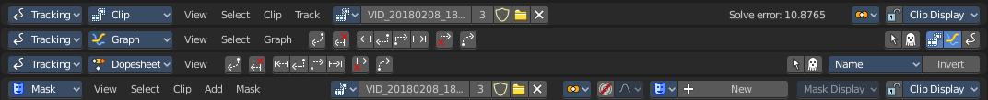

Movie Clip prop

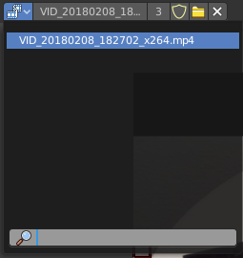
Available in Tracking in Clip mode and Mask mode.
This property contains the list of loaded movie clips. When no movie clip is loaded or active, then it displays the Open Buttons. When a movie clip is loaded and active, then it displays the name of the currently active movie clip.

From left to right ...

List of clips in the scene
This is a list of the movie clips in the scene. Allows you to witch to other images.

Search form
Search for specific clips.

Clip Edit Box
The name of the currently selected movie clip. You can rename the movie clip here too.

Number of Fake Users
In case this file has a fake user assigned, then this number displays the number of fake users.

Fake User
With this button you assign a fake user to this selected image.
Data, like images, that is not longer linked to anything else gets removed when you save and reload a scene. Bforartists has the concept of fake users to go around this behaviour. An image with a fake user is in fact linked to something. And so it is not lost when you save and reload the scene.

Open
Open a new movie clip.

Remove
Removes the movie clip. Note that it will not be removed when it has a fake user assigned. Then the clip becomes simply inactive. You can still use it from the list again.

Info String

Available in Tracking in Clip mode.

A string, giving you some informations about the scene. In this case the number of solve errors for the curent tracking.

Pivot Point
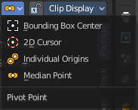
Available in Tracking in Clip mode and Mask mode.

Adjust the pivot point for transform operations. The names should be self explaining.

Lock to Selection

Available in Tracking in Clip mode.
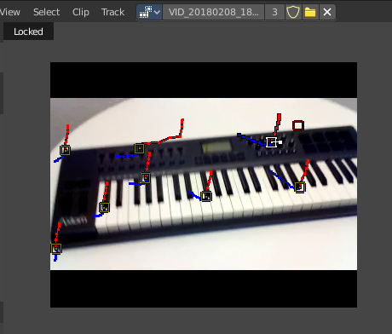
With lock to selection disabled the viewport stands still and the markers moves. With lock to selection enabled the view is centered at the current selected marker, and the video moves around.

When locked is activated, then you will see a Locked string up left in the viewport.

Clip Display

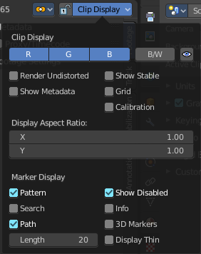
Available in Tracking in Clip mode and Mask mode.

Display options for the tracking footage.

Clip Display

R G B
Display the red green and blue channels of the footage

BW
Display the footage in black and white.

Mute Footage
Hide the footage.

Render Undistorted
Render Preview undistorted.

Show Metadata
Shows the metadata of the clip if available.

Show Stable
Show stable footage in editor. Stabilization needs to be enabled.

Grid
Displays a red grid over the footage that displays the lens distortion.

Calibration
Use manual calibration helpers.

Display Aspect Ratio X Y
The aspect ratio to display the footage.

Marker Display

Pattern
Displays the rectangles around the markers.

Search
Shows a search boundbox around the currently selected marker.

Path
Shows the paths for the markers.
Note that this checkbox disables also Pattern, Search and Length when you turn it off.

Length
How much of the path is displayed before and after the current position in the movie clip.

Show Disabled
Show also disabled markers.

Info
Displays a information string at the currently selected markers.

3D Markers
Displays a green dot at the center of the marker.

Display Thin
Displays the markers, markerwidgets and markerlines with thin lines.

Marker Tools
Available in Tracking mode in Graph and Dopesheet mode.

Tools to refine and modify the markers.

Refine Markers Backwards
Refine selected markers position by running the tracker from tracks reference to current frame.

Clear Track Path Backwards
Clear tracks before the current position.

Track Markers Backwards
Track selected markers backwards.

Track Markers Sequence Backwards
Track selected marker sequence backwards.

Track Markers Sequence Forwards
Track selected marker sequence forwards.

Track Markers Forwards
Track selected markers forwards.

Clear Track Path Forwards
Clear tracks after the current position.

Refine Markers Forwards
Refine selected markers position by running the tracker from tracks reference to current frame.

Graph editor Options

Only selected
Only display channels relating to the current objects and data.

Display Hidden
Display also channels from objects/bones that are not visible.

Show Frames
Show curve for per frame average error. Camera motion should be solved first.

Show Track Motion
Display the speed curves for the selecterd tracks. Red is X direction. Green is Y direction.

Show Tracks Error
Display the reprojction error curve for the selected tracks.

Dopesheet editor Options

Only selected
Only display channels relating to the current objects and data.

Display Hidden
Display also channels from objects/bones that are not visible.

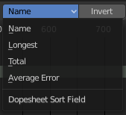
Dopesheet Sort Field
Sort the list of the tracks by chosen method.

Invert
Invert the sort order of dopesheet channels.

Proportional Editing

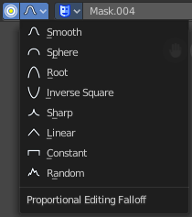
Proportional Editing
Enables proportional editing.
Proportional Editing is a way of transforming selected elements (such as vertices, or in this case the handlers for the mask spline curves) while having that transformation affect other nearby elements with a falloff. For example, moving a single vertex will move unselected vertices within a given range. And the falloff means that selected vertices that are closer to the selected vertex will move more than those farther from it.

Settings
Choose between different falloff methods for the proportional editing. The settings are hidden when you have proportional editing off.

Mask Prop

Mask Prop
When you are in Mask mode then you can create a new mask, and work with this mask then.
Masks have many purposes. They can be used to mask out, or influence a particular object in the footage in Motion tracking. They can be used for manual rotoscoping to pull a particular object out of the footage. They can be used as a rough matte for green-screen keying.
Masks are independent from a particular image of movie clip, and so they can also be used for creating motion graphics or other effects in the compositor.
Masks can be driven over the time so that they follow some object from the footage. For example a running actor. This can be achieved with shape keys or parenting the mask to tracking markers.

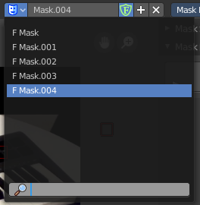
List of Masks
This is a list of the masks in the scene. Allows you to switch to other masks.

Mask Edit Box
The name of the currently selected mask. And you can rename the image mask too.

Fake User
Wit this button you assign a fake user to this selected mask. Masks gets created with a fake user already. Means when you save the scene and reopen it, then this mask will still be there.
Data, like images, that is not longer linked to anything else gets removed when you save and reload a scene. Bforartists has the concept of fake users to go around this behaviour. An image with a fake user is in fact linked to something. And so it is not lost when you save and reload the scene.

Search form
Search for specific masks.

Mask Display

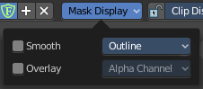
Mask Display
In Mask mode and with a Render result. Adjust the display of the mask.

Smooth
Smoothens the outline of the mask curve.

Overlay
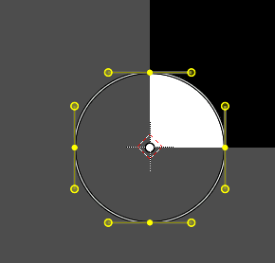
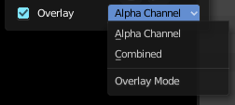
When it's a closed curve then this closed area gets displayed as filled where it covers the image. When you tick Overlay then a second dropdown box becomes active

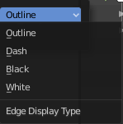
Edge Display Type
The mask curve can be displayed in different styles.

